MSSQL SERVER
Standard Operating Procedures
(SOP)
MSSQL Refresh/Restore Checklist

Submitted to



BY



CIS, Wipro Limited

Document Details

Project Name | Innogy SE
Account | CIS
IT Component/Application Title | MSSQL Refresh/Restore Checklist
Current Version | 1.2
List of Contributors | Pradipkumar Kansara, Kiran Bhalekar, Ayushi Gautam, Sivakumar Goud, Shikha Verma, Pramod Patil
Customer Contact Information
Version History
(All revisions made to this document must be listed in chronological order. All revisions must be approved. Review and Approval can be done by an internal source or by the customer)
Version | Date of Revision | Description | Author | Reviewed By | Approved By
1.0 | 20-04-2018 | Initial Draft | Shikha Verma | Pradipkumar Kansara | Santosh Badiger
1.1 | 08-05-2018 | Document Completed | Shikha Verma | Pradipkumar Kansara | Santosh Badiger
1.2 | 20-12-2018 | Updated the content | Pramod Patil | Pradipkumar Kansara | Santosh Badiger

Purpose
The purpose of this document is to discuss the pre-requisites and post checks that need to be taken care at the time of performing Restore/Refresh activity.

Scope

Once you develop a good backup plan for Microsoft SQL Server, you will need to learn how to restore your data when necessary. You might want to restore your data because of a failure or you may want to restore data to a backup or standby server. The reasons are endless, but the most important thing is to be ready.

Introduction / Overview

The backup and restore components of Microsoft® SQL Server™ allows you to create a copy of a database. This copy is stored in a location protected from the potential failures of the server running the instance of SQL Server. If the server running the instance of SQL Server fails, or if the database is somehow damaged, the backup copy can be used to re-create, or restore, the database.

Detailed Procedure

Prior performing Refresh/Restore activity.

- Check the space on source server where data files are placed.

- Check how many data files are present in database and size of the files on source server.

- Check the size of the destination drive where backup files need to be placed.
If space is not sufficient on destination drive, calculate the additional space which is required and raise a SAN allocation change.

- List all the users information (in excel sheet ) of the database whose restore need to be perform by using sp_helpuser.

- We need to ensure that there should be no issues due to compression of backup at source and when there is no compression software(Hyper Backup) at the destination :

- Hyper Backup enabled at both source and destination server : No issues in restoring.
- Hyper Backup is enabled at source but not at destination – We get error while restoring, so either we have to stop the hyper backup at source and then take full and fresh backup (This would be uncompressed backup) and then restore this backup file at destination OR we have to install and enable hyper backup at the destination and then restore the compressed backup from the source.

- To check whether backup file is corrupted or not, use VERIFYONLY command.
RESTORE VERIFYONLY FROM DISK = C:\AdventureWorks.BAK
GO

If backup file(.bak) is corrupted, take a fresh backup and try restoring the same.

- While restoring the database, You might get error as mentioned below.

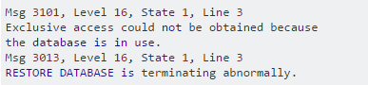

This error is occurring since someone is trying to access the database while the restore is trying to do a restore. Use below script and you will be able to restore by taking database offline.
ALTER DATABASE [ResAQReview] SET OFFLINE WITH
ROLLBACK IMMEDIATE
GO
restore database ResAQReview from disk = 'G:\ResAQReview_07_Backup.BAK'
with replace,
move 'ResAQReviewProd_Data' to 'E:\MSSQL12.SDB141T\MSSQL\DATA\ResAQReview.MDF',
move 'ResAQReviewProd_Log' to 'F:\MSSQL12.SDB141T\MSSQL\Logs\ResAQReview.LDF'

Health checks to be performed after Refresh/Restore activity.

  - Check owner of the database. If owner is other than SA, change it to SA.

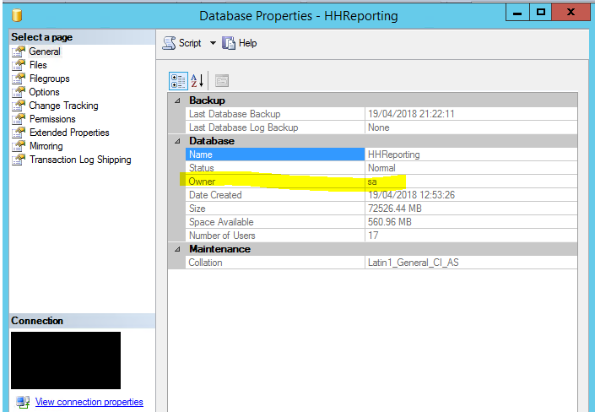

  - Check for any orphaned users on the database.

EXEC sp_change_users_login 'Report'

If any orphaned users found, then fix the users login by running below script.

EXEC sp_change_users_login 'Auto_Fix', 'user'
EXEC sp_change_users_login 'Auto_Fix', 'user', 'login', 'password'

- Check the list of users (taken before refresh) and compare with the current users present in the database, if any user permissions are missing, then map the user with the data which was taken before refresh.

- Delete the backup file from the drive, post successful restore of the database.

